Microservices Report Stage 2
Name: Hafsa Moin
Student ID: D00256764
Table of Contents
Application Overview 1
Istio Architecture Overview 1
Control Plane - istoid 1
Data Plane - Envoy Proxies 1
How Istio and Envoy Control Traffic 2
Secure Communications 2
Mutual TLS 2
Zero Trust - Authorization Policies 3
Traffic Control 3
Load Balancing 3
Canary Deployment 3
Observability 4
Prometheus and Grafana 4
Distributed Tracing – Jaeger 5
Cluster Topology – Kiali 6
Resilience Features 6
Rate Limiting 6
Circuit Breaker 7
Fault and Chaos Testing 7
Sidecar vs Ambient Mode 8
Sidecar Mode 8
Ambient Mode 8
L4 vs L7 and Ambient L7 9

Application Overview
The application is an event-driven e-commerce backend made up of three microservices: Order Service, Inventory Service, and Payment Service. Services communicate asynchronously through Apache Kafka, and each service has its own Redis instance for state management. Zookeeper is used to coordinate Kafka. The application is deployed in a Kubernetes namespace called microsvc using Kustomize, and an Istio ingress gateway exposes it externally.
Component | Type | Purpose
order-service | Stateless (Deployment) | Creates and tracks orders
inventory-service | Stateless (Deployment) | Manages product stock levels
payment-service | Stateless (Deployment) | Handles payment processing
kafka | Stateful (StatefulSet) | Async event bus between services
zookeeper | Stateful (StatefulSet) | Kafka coordination

Istio Architecture Overview
Istio is a service mesh; a dedicated infrastructure layer that handles service-to-service communication. It sits between your application code and the network, giving you security, observability, and traffic control without changing the application itself.
Istio has two main components:

Control Plane - istoid
istiod is a single process that handles everything on the control side:
- Pilot; takes the Istio configuration (VirtualServices, DestinationRules, etc.) and converts it into Envoy proxy configuration. It pushes this config to every sidecar in the mesh using the xDS API.
- Citadel; manages certificates. It issues and rotates X.509 certificates for every workload, which are used for mTLS.
- Galley; validates and distributes Istio configuration.

Data Plane - Envoy Proxies
Every application pod gets an Envoy proxy injected as a sidecar container. Envoy intercepts all inbound and outbound traffic for the pod using iptables rules set up by an init container. The application has no awareness of this; it thinks it is communicating directly.

How Istio and Envoy Control Traffic
When a request is made from one service to another, the following happens:
- The application makes a normal HTTP call (e.g. http://order-service:8000/orders).
- iptables rules inside the pod redirect this outbound traffic to the local Envoy sidecar (port 15001).
- Envoy checks its configuration; routing rules, load balancing policy, retry rules, circuit breaker state.
- Envoy initiates an mTLS connection to the destination pod’s Envoy sidecar.
- The destination Envoy checks the incoming connection against the AuthorizationPolicy.
- If allowed, it forwards the request to the local application container.
- Both Envoy sidecars record telemetry (metrics, traces, access logs) and send it to Prometheus and Jaeger.
This means every single feature; mTLS, retries, rate limiting, fault injection; happens at the proxy layer with no code changes to the application.

Secure Communications

Mutual TLS
Mutual TLS (mTLS) means both sides of a connection verify each other’s identity using certificates, unlike regular TLS where only the server is verified. Istio automates this entirely; it issues certificates to each workload using SPIFFE (Secure Production Identity Framework), and Envoy handles the handshake.
The following PeerAuthentication policy enforces STRICT mTLS across the entire microsvc namespace. STRICT means plaintext connections are rejected; every service must present a valid certificate.
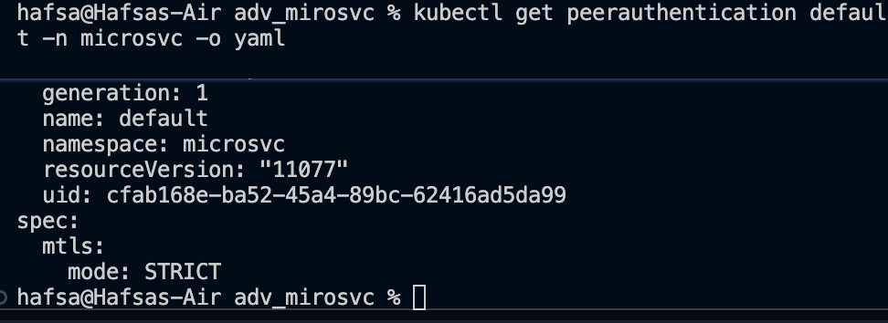
To verify enforcement, a pod was created in the default namespace (outside the mesh, no Envoy sidecar). It attempted to connect directly to order-service:
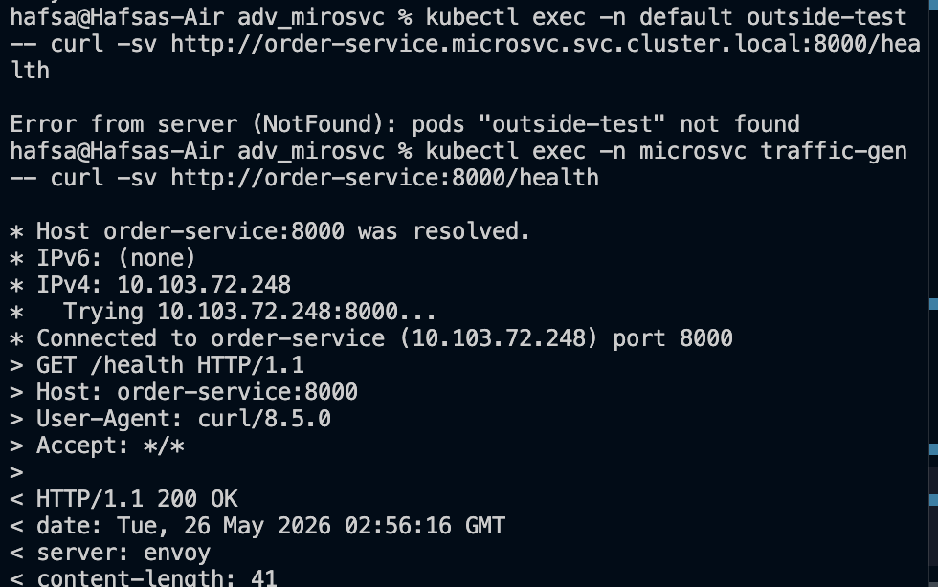
The connection was reset at the transport layer because the pod had no sidecar and could not complete the mTLS handshake. The application was never reached.

Zero Trust - Authorization Policies
Zero trust means traffic is denied by default and only explicitly permitted flows are allowed. This is implemented using Istio AuthorizationPolicy resources.
A namespace-wide policy is applied alongside three service-specific ALLOW policies. Each ALLOW policy restricts which HTTP methods and paths are permitted, and only allows traffic originating from within the microsvc namespace.
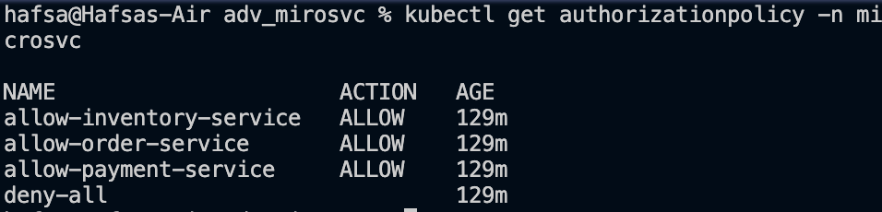
For example, the order-service policy only permits GET and POST requests on /orders* and /health from within the namespace.

Traffic Control

Load Balancing
Load balancing is configured through DestinationRule resources. All three services use ROUND_ROBIN, which distributes requests evenly across available pods in sequence.
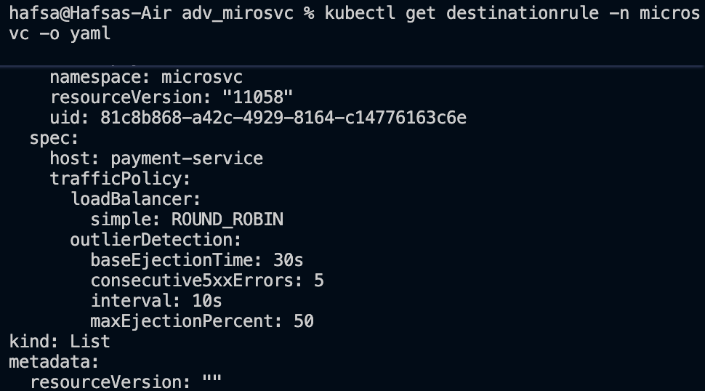
This is enforced at the Envoy layer. When a request goes to order-service, Envoy selects the next available pod in round-robin order, independent of the application.

Canary Deployment
A canary deployment allows a new version of a service to receive a small percentage of real traffic while the stable version handles the rest. This lets you test a new release with minimal risk before fully rolling it out. Two versions of order-service are deployed: v1 (stable, 80%) and v2 (canary, 20%). The traffic split is controlled by a VirtualService. The subsets (v1 and v2) are defined in the DestinationRule using pod labels:
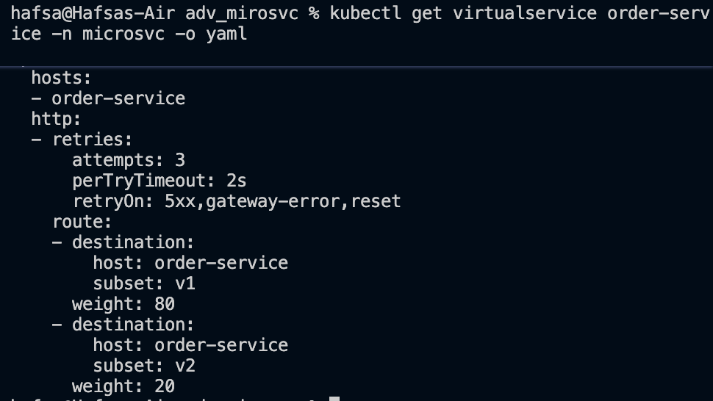
80-20 rule:
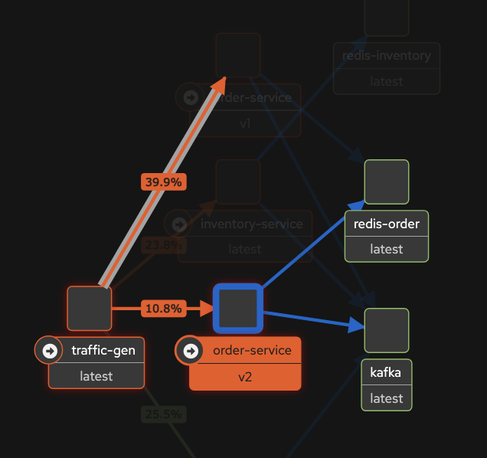

Observability

Prometheus and Grafana
Envoy automatically emits metrics for every request it handles. These are scraped by Prometheus without any instrumentation in the application code. Key metrics include:
- istio_requests_total; total request count, labelled by source, destination, method, and response code
- istio_request_duration_milliseconds; request latency histogram

The following Prometheus queries were used to observe live traffic:
Query 1 - Request rate per service:
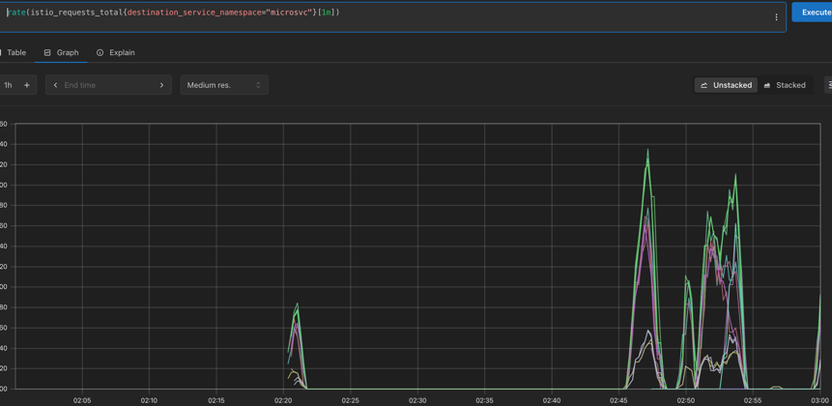

Query 2 - p99 latency:
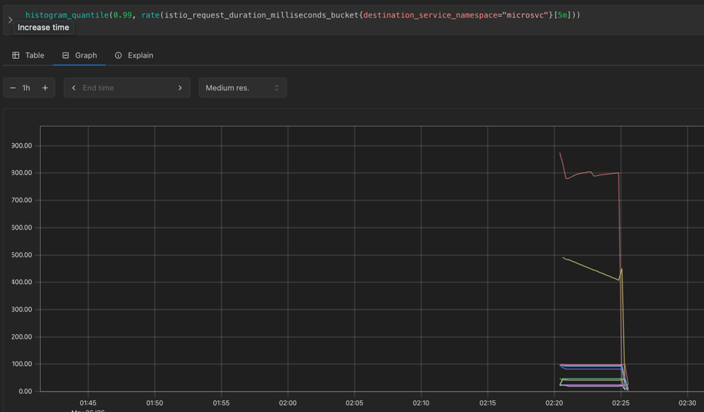
Grafana provides pre-built Istio dashboards on top of these metrics. The Istio Service Dashboard for order-service shows requests by response code, success rate, and request duration. The Grafana dashboard also confirms mTLS; every traffic source in the legend is labelled with a lock icon and mTLS.
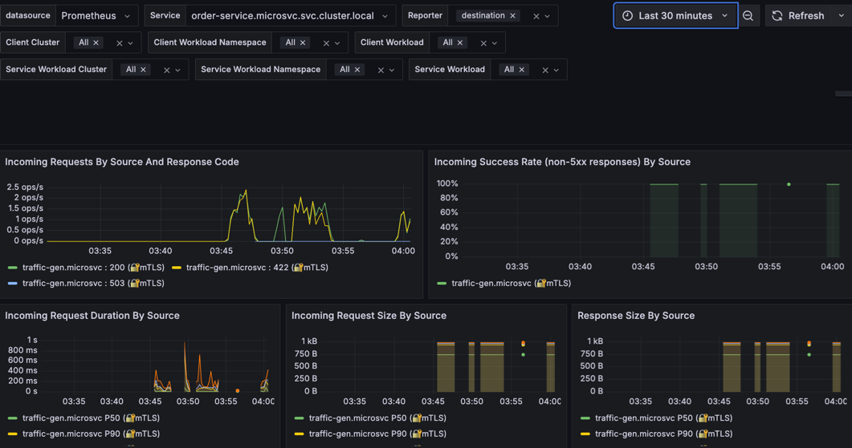

Distributed Tracing – Jaeger
Distributed tracing shows the path a single request takes through multiple services. Istio’s Envoy sidecars automatically generate trace spans for every request and forward them to Jaeger using the OpenTelemetry protocol. Tracing was enabled using a Telemetry resource pointing to the Jaeger provider defined in the Istio mesh config. 100% sampling ensures every request generates a trace, which is suitable for a test environment.
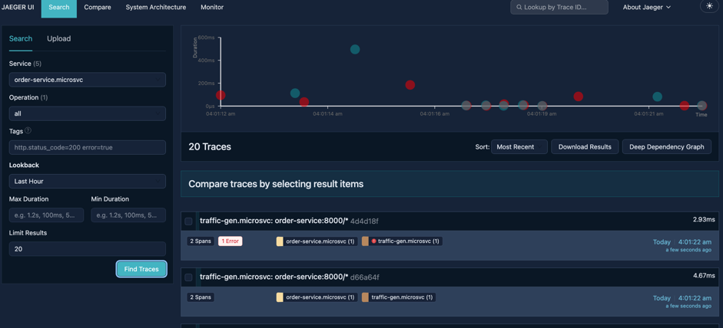
Each trace shows how long each hop took, which service handled it, and whether any errors occurred. This is essential for diagnosing latency issues in a distributed system.

Cluster Topology – Kiali
Kiali is a management console for Istio that visualises the service mesh topology in real time. It shows which services are communicating, traffic rates, error rates, and security status.
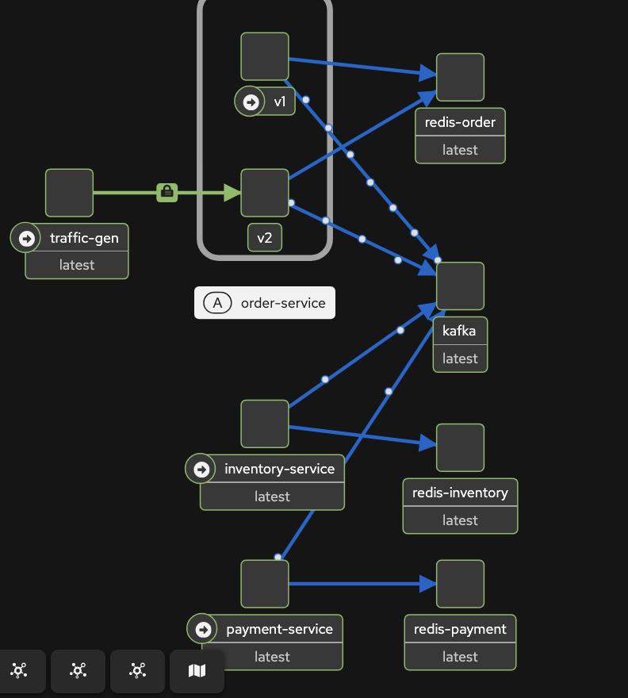
The padlock icons on every edge confirm that all inter-service communication is encrypted with mTLS. The animated traffic dots show live request flow through the mesh.

Resilience Features

Rate Limiting
Rate limiting prevents a single client from overwhelming a service by capping the number of requests allowed in a time window. This is implemented using an Envoy local rate limiter via an EnvoyFilter resource. The filter is applied to the inbound listener of order-service and allows a maximum of 10 requests per 60 seconds per instance. When the limit is exceeded, Envoy returns HTTP 429 Too Many Requests and adds an x-local-rate-limit: true header.
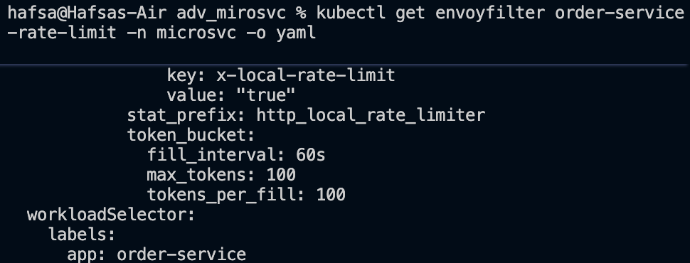
Test - sending 20 rapid requests:
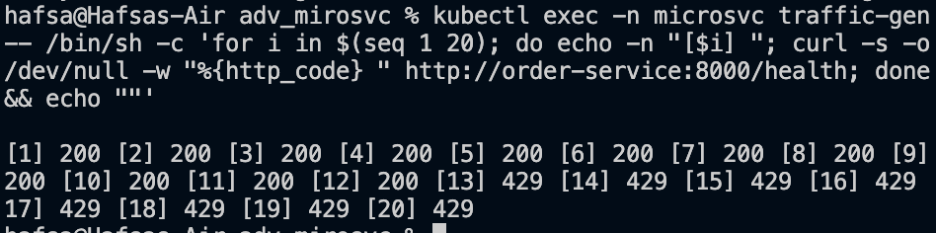
The rate limit is enforced at the proxy level, so it fires before the request reaches the application.

Circuit Breaker
A circuit breaker detects unhealthy instances and stops sending them traffic temporarily, preventing a slow or failing pod from degrading the whole service. In Istio this is called outlier detection and is configured in DestinationRule. This means that if a pod returns 5 consecutive 5xx errors within a 10-second window, it is ejected from the load balancing pool for 30 seconds. At most 50% of instances can be ejected at any time, ensuring the service remains available.
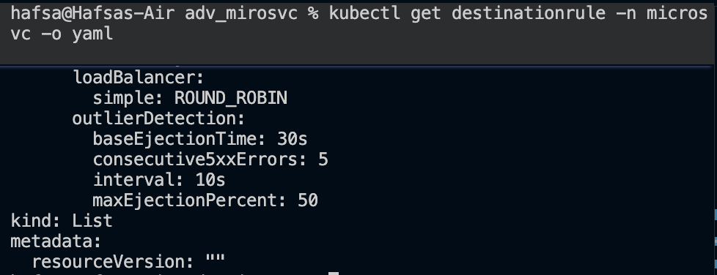
This works in combination with the fault injection test; when the inventory-service returns 503 errors due to injected faults, Envoy tracks the consecutive failures and will eject the instance once the threshold is reached.

Fault and Chaos Testing
Fault injection lets you simulate failures in a controlled way to observe how the system behaves under degraded conditions. Istio injects faults at the Envoy proxy layer, so the application itself is unmodified.
Two types of fault were injected into inventory-service:
- Delay - 10% of requests are delayed by 5 seconds, simulating network latency or a slow downstream dependency
- Abort - 50% of requests return HTTP 503, simulating a service failure
Test – 50 requests to inventory-service/health:
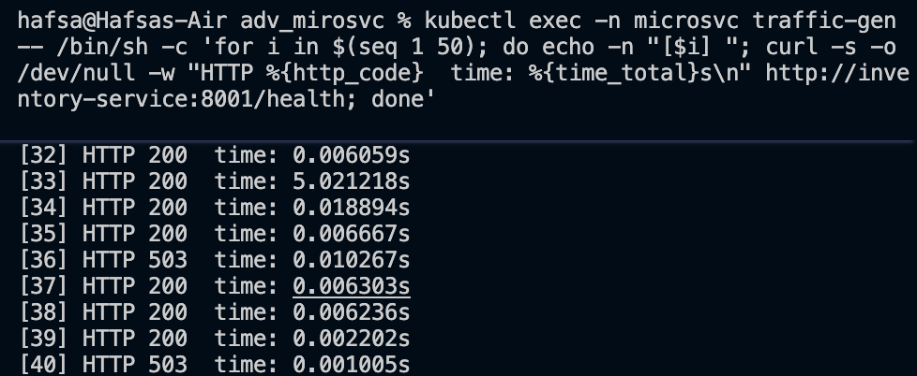

The results show:
Normal fast responses (approximately 0.01 seconds); no fault applied
Delayed responses (around five seconds); 5-second delay injected by Envoy - 503 responses; abort fault injected by Envoy. This demonstrates that the system degrades gracefully when a dependency becomes slow or unavailable, and provides a baseline to evaluate the impact of the circuit breaker and retry policies also configured on the service. The retries configured in the VirtualService (3 attempts, 2s timeout per attempt) also activate during this test; when Envoy receives a 503, it automatically retries the request up to 3 times before returning the error to the client.

Sidecar vs Ambient Mode
Istio offers two deployment models: Sidecar (the traditional model) and Ambient (the newer model introduced in Istio 1.22). This project uses Sidecar mode.

Sidecar Mode
In sidecar mode, every application pod gets an Envoy proxy injected as a second container. The proxy intercepts all traffic using iptables rules set up at pod startup.
Pros:
- Per-pod isolation; each workload has its own proxy with its own config and resource limits
- Full L7 visibility; headers, paths, methods, and payloads are all inspectable per pod - Mature and well-documented; has been the standard for years
- Fine-grained policy per workload
Cons:
- Resource overhead; every pod runs an additional Envoy container using CPU and memory
- Operational complexity; sidecars must be restarted when Istio upgrades, requiring pod restarts
- Slow rollout; adding the mesh to existing workloads requires restarting every pod - iptables interception adds latency (typically 1-5ms per hop)

Ambient Mode
Ambient mode removes the per-pod sidecar entirely. Instead, it uses two new components:
- ztunnel; a node-level proxy (runs once per node, not per pod) that handles L4 traffic, mTLS, and basic policy
- waypoint proxies; optional per-namespace or per-service Envoy proxies that handle L7 features when needed

Pros:
- Much lower resource consumption; one ztunnel per node instead of one sidecar per pod
- No pod restarts needed to join or leave the mesh
- Simpler operations; upgrading ztunnel does not require restarting application pods
- Better for large clusters where sidecar overhead becomes significant
Cons:
- Newer and less mature; ambient mode reached stable in Istio 1.24 (2024)
- L7 features require deploying a waypoint proxy, which adds complexity back
- Less per-pod isolation; all pods on a node share the same ztunnel
- Debugging is harder; traffic path is less obvious than a sidecar sitting next to the app - Some Istio features are not yet fully supported in ambient mode
Comparison Table
Feature | Sidecar | Ambient
Resource use | High (per pod) | Low (per node)
L4 mTLS | Yes | Yes (ztunnel)
L7 policies | Yes (always) | Yes (waypoint only)
Pod restarts for mesh join | Yes | No
Maturity | High | Medium
Operational complexity | Medium | Lower (without waypoints)

L4 vs L7 and Ambient L7
L4 refers to the transport layer of the OSI model; TCP and UDP. At L4, traffic is understood only in terms of IP addresses, ports, and connection state. There is no awareness of what is inside the packets. In Istio, L4 features include:
- mTLS - encrypts the TCP connection and verifies workload identity using certificates
- Basic connection-level authorization (allow/deny by source IP or service account)
- TCP metrics (bytes in/out, connection count)
- ztunnel in ambient mode operates at L4. It can secure all TCP traffic with mTLS and enforce basic identity-based policies without looking at HTTP content.
L7 refers to the application layer; HTTP, gRPC, headers, paths, methods. At L7, the proxy understands the semantics of the request. In Istio, L7 features include:
- Header-based routing and traffic splitting (VirtualService)
- Path and method-based authorization (AuthorizationPolicy with HTTP conditions)
- Retries, timeouts, and fault injection
- Request-level metrics (RPS, latency per route, status code breakdown) - Distributed tracing
Sidecar mode always operates at L7 for HTTP traffic. Every request is fully parsed by Envoy.
In ambient mode, ztunnel only operates at L4. To get L7 features, you must deploy a waypoint proxy, which is essentially a standalone Envoy deployment scoped to a namespace or service account. Client Pod > ztunnel (L4 – mTLS) > Waypoint Proxy (L7) > Server Pod > ztunnel (L4 – mTLS).
A waypoint is deployed with: istioctl waypoint apply --namespace microsvc. Once deployed, all L7 AuthorizationPolicy, and VirtualService rules for that namespace are enforced by the waypoint rather than by per-pod sidecars. This gives you the full L7 feature set without injecting a sidecar into every pod, but the waypoint itself becomes a component you need to manage and scale. The key trade-off is: if you only need mTLS, and basic identity-based access control, ambient mode with just ztunnel is sufficient, and very lightweight. If you need HTTP-level routing, retries, or fine-grained path policies, you need a waypoint, which brings back some of the operational overhead ambient mode was designed to avoid.

